SESHADRIPURAM EDUCATIONAL TRUST
SESHADRIPURAM COLLEGE
POST GRADUATE DEPARTMENT OF COMPUTER APPLICATIONS
#27, Nagappa Street, Seshadripuram, Bengaluru – 560020
Permanently Affiliated to Dr. Manmohan Singh Bengaluru City University | AICTE Approved
ISO 9001:2015 Certified | NAAC Grade: A++

PROJECT REPORT ON
AutoQA Framework: End-to-End Test Automation using Playwright and TypeScript
Automated Quality Assurance Framework for UI and API Testing
Submitted in partial fulfillment for the award of the degree of
MASTER OF COMPUTER APPLICATIONS (MCA)
IV Semester
Submitted by
Pradeep Kumar H N – P18GH24S126076
Under the Guidance of
Prof. Vijayalakshmi S Katti
Academic Year: 2025 – 26

Certificate
This is to certify that the major project entitled “AutoQA Framework: End-to-End Test Automation using Playwright and TypeScript”, carried out by Pradeep Kumar H N (P18GH24S126076), has been completed in the Post Graduate Department of Computer Applications, Seshadripuram College, during the academic year 2025–26, under the guidance of Prof. Vijayalakshmi S Katti.
The project report has been prepared under the guidance stated above and, to the best of our knowledge, represents an independent and original piece of work by the candidate, carried out in partial fulfillment of the requirements for the award of the degree of Master of Computer Applications (MCA).

Signature of the Guide  Prof. Vijayalakshmi S Katti | Signature of the Head of the Department
Signature of the Principal | Signature of the External Examiner

Declaration
I, Pradeep Kumar H N (P18GH24S126076), hereby solemnly declare that the major project entitled “AutoQA Framework: End-to-End Test Automation using Playwright and TypeScript” is a bonafide work carried out by me under the guidance of Prof. Vijayalakshmi S Katti, Post Graduate Department of Computer Applications, Seshadripuram College, Bengaluru.
This project is my original work and has not been submitted, either in part or in full, for the award of any other degree, diploma, associateship, or fellowship of this or any other university or institute.
Place: Bengaluru
Date:
Pradeep Kumar H N
(P18GH24S126076)

Acknowledgement
I express my sincere gratitude to the management and faculty of Seshadripuram College and to my guide, Prof. Vijayalakshmi S Katti, for their guidance and support throughout this project.
I extend my heartfelt thanks to the Head of the Department and the faculty members of the Post Graduate Department of Computer Applications, Seshadripuram College, Bengaluru, for providing the necessary facilities, resources, and academic environment that made this work possible.
I am also thankful to my family, friends, and peers for their continuous support and motivation during the course of this project.
Pradeep Kumar H N

Abstract
This project presents AutoQA Framework, a maintainable end-to-end test automation framework for web user interfaces and REST APIs. The framework is implemented with TypeScript and Playwright and is organized around reusable browser actions, API actions, page objects, environment configuration, test fixtures, and multiple reporting adapters.
The framework targets the DemoQA web application for functional browser testing and uses both a local JSON Server employee service and the DemoQA Swagger Book Store API for API validation. Browser tests are configured for Chrome, Firefox, and WebKit, while API tests run through dedicated Playwright projects. The configuration supports QA, development, QA API, and development API environments without changing test source code.
The solution also demonstrates reporting and diagnostics through the Playwright HTML report, Allure, Ortoni HTML reporting, screenshots, video, traces, and framework logs. A GitHub Actions workflow installs Node.js 20 and Playwright dependencies, executes UI and API suites, generates reports, and uploads artifacts. The result is a reusable foundation that reduces duplicated automation code and provides a consistent execution model for local development and continuous integration.
The complete source code for AutoQA Framework is available at: https://github.com/FamousAnonymous/AutoQAFramework

Table of Contents
List of Figures
List of Tables
Chapter 1 – Introduction
1.1 Background and Motivation
1.2 Characteristics of a Good Automation Framework
1.3 Applications of Automated Quality Assurance
Chapter 2 – Literature Review
2.1 Existing Approaches and Tools
2.2 Technology Survey
2.3 Limitations of Existing Approaches
2.4 Proposed Framework
Chapter 3 – Methodology
3.1 Problem Statement
3.2 Objectives
3.3 Scope and Modules
3.4 Out-of-Scope Components
Chapter 4 – Requirements Specification
4.1 Hardware and Software Requirements
4.2 Functional Requirements
4.3 Non-Functional Requirements
4.4 Development and Execution Environment
Chapter 5 – Analysis and Design
5.1 System Architecture
5.2 Test Execution Flow
5.3 Page Object and Action Design
5.4 Reporting and CI Design
Chapter 6 – Implementation and Results
6.1 Framework Implementation
6.2 UI Test Implementation
6.3 API Test Implementation
6.4 Configuration, Data, and Diagnostics
6.5 Continuous Integration
6.6 Results and Generated Artifacts
6.7 Report Screenshots (Allure, Playwright HTML, Ortoni)
Chapter 7 – Testing
7.1 Test Strategy
7.2 Coverage Matrix
7.3 Defect Diagnostics and Evidence
Chapter 8 – Conclusion and Future Enhancements
8.1 Summary
8.2 Future Enhancements
8.3 Limitations
References

List of Figures
Figure 5.1: System Architecture – AutoQA Framework
Figure 5.2: Sequence Diagram – Test Execution Flow
Figure 5.3: Class / Module Diagram – Core Framework Components

List of Tables
Table 2.1: Comparison of Existing Approaches and the Proposed Framework
Table 4.1: Hardware and Software Requirements
Table 4.2: Key Dependencies and Environment Keys
Table 6.1: Generated Report and Diagnostic Artifacts
Table 7.1: Test Coverage Matrix by Specification File
Table 7.2: Detailed Test Cases – Elements.test.ts
Table 7.3: Detailed Test Cases – Widgets, Interactions, and HAR
Table 7.4: Detailed Test Cases – AlertsFrameWindows.test.ts
Table 7.5: Detailed Test Cases – Login.test.ts
Table 7.6: Detailed Test Cases – MockCrud.test.ts (Employee CRUD)
Table 7.7: Detailed Test Cases – SwaggerBookStore.test.ts (Book Store API)

Chapter 1 – Introduction
1.1 Background and Motivation
Modern web applications combine browser workflows, asynchronous network calls, third-party services, and responsive user interfaces. Manual regression testing of such applications is repetitive, slow, and vulnerable to inconsistent execution. A test automation framework addresses this problem by providing repeatable test execution, reusable abstractions, diagnostics, and machine-readable results.
AutoQA Framework was developed as a practical Playwright and TypeScript solution for validating both browser interactions and API contracts. The project uses DemoQA as the public UI and Book Store target and a local JSON Server database as a deterministic CRUD target. This combination demonstrates how one framework can validate user-visible behaviour and service-level behaviour while keeping environment-specific details in configuration.
1.2 Characteristics of a Good Automation Framework
A good framework should be readable, modular, deterministic, configurable, diagnosable, and suitable for continuous integration. Tests should express business intent rather than low-level selector and request mechanics. Common actions should be centralized, page-specific locators should be isolated in page objects, and failures should preserve enough evidence for rapid investigation.
The framework addresses these characteristics through a fixture-based BaseTest, WebActions, APIActions, page repository classes, Playwright projects, environment maps, custom reporting, and failure artifacts. It also avoids a single hard-coded execution path by allowing the same test suite to run against different configured environments.
1.3 Applications of Automated Quality Assurance
The framework can be used for smoke testing after deployment (via @Smoke-tagged tests), functional regression testing, API contract checks, cross-browser compatibility testing, release verification, and continuous integration gates. Its reporting outputs are suitable for developers, testers, and project reviewers because they include test status, timing, attachments, traces, and execution context.
Chapter 2 – Literature Review
2.1 Existing Approaches and Tools
Traditional UI automation commonly uses Selenium-style driver abstractions, while API validation may use separate tools such as Postman collections or standalone HTTP clients. These tools are useful, but maintaining separate languages, runners, configuration files, and reporting pipelines can increase duplication. Playwright provides browser automation, request contexts, parallel projects, tracing, screenshots, and a unified test runner in one ecosystem.
2.2 Technology Survey
TypeScript supplies static typing and editor support for test code. Playwright Test supplies fixtures, projects, retries, reporters, browser contexts, and API request support. JSON Server supplies a small local REST service for deterministic CRUD testing. Allure and Ortoni provide additional result views, while GitHub Actions supplies a repeatable cloud execution environment.
2.3 Limitations of Existing Approaches
Large end-to-end suites can become slow when every test starts from a full browser flow. Public websites can also change selectors or be affected by network availability. Test data can become polluted when API tests modify shared records. A framework must therefore separate environments, isolate test data where practical, retain diagnostics, and use stable abstractions without hiding real failures.
2.4 Proposed Framework
The proposed solution combines reusable action classes, page objects, environment-driven configuration, independent UI and API projects, local mock data, multi-reporter output, and CI artifact publication. The design is intentionally transparent: test files remain visible and traceable to the application behaviour they verify.

Feature | Selenium-style Tools | Postman / Standalone API Tools | AutoQA Framework (Proposed)
Browser Coverage | Wide, but needs extra sync libraries | Not applicable | Native Chromium, Firefox, WebKit
API Testing | Requires separate library | Strong, but separate tool/language | Integrated via Playwright request context
Reporting | Depends on added plugins | Collection-run reports only | HTML, Allure, and Ortoni reporters
Unified Runner | Not by default | No | Single Playwright Test runner for UI + API
CI/CD Readiness | Possible with extra setup | Possible with Newman | Native GitHub Actions workflow
Maintenance Overhead | Higher (multiple tools/configs) | Higher (separate pipeline) | Lower (single TypeScript codebase)

Table 2.1: Comparison of Existing Approaches and the Proposed Framework
Chapter 3 – Methodology
3.1 Problem Statement
The project addresses the need for a single, maintainable automation framework that can validate UI workflows and REST APIs across browsers and environments while producing useful evidence when a check fails.
3.2 Objectives
The objectives are to build a TypeScript Playwright framework; implement reusable UI and API abstractions; cover representative DemoQA workflows; validate local CRUD and Swagger Book Store APIs; support Chrome, Firefox, and WebKit projects; provide environment configuration; generate HTML, Allure, and Ortoni reports; preserve screenshots, videos, and traces on failure; and execute the same checks in GitHub Actions.
3.3 Scope and Modules
The scope includes browser navigation, form interaction, element validation, alerts and frames, widgets, login and book-store workflows, HAR-backed behaviour, employee CRUD operations, Swagger Book Store operations, configuration, reporting, and CI execution. The principal modules are the test runner configuration, shared action libraries, page repository, functional test suites, API test suites, mock database, reporters, and workflow automation.
3.4 Out-of-Scope Components
The project does not implement performance/load testing, mobile-native automation, penetration testing, production database integration, visual baseline governance, or a business application under test. Those capabilities can be integrated later without changing the core execution model.
Chapter 4 – Requirements Specification
4.1 Hardware and Software Requirements
A developer machine requires a modern multi-core processor, at least 8 GB RAM, sufficient storage for Node modules and browser binaries, Windows or Linux, Node.js 20 or later, npm, and the Playwright browser dependencies. CI uses an Ubuntu runner and installs the required browser dependencies before execution.
Component | Specification
Processor | Modern multi-core processor (Intel i5 or equivalent, or higher)
RAM | 8 GB minimum
Storage | Sufficient free space for Node modules, browser binaries, and reports
Operating System | Windows or Linux (development); Ubuntu (CI runner)
Runtime | Node.js ≥ 20.0.0 (per package.json engines field)
Package Manager | npm
Automation Library | Playwright (@playwright/test ^1.60.0)
Table 4.1: Hardware and Software Requirements
4.2 Functional Requirements
- FR1: The framework shall execute functional UI tests against the configured base URL.
- FR2: It shall support Chrome, Firefox, and WebKit browser projects.
- FR3: It shall execute local employee CRUD API tests.
- FR4: It shall execute Swagger Book Store API tests.
- FR5: It shall select environment URLs through the ENV setting.
- FR6: It shall generate HTML and additional test reports.
- FR7: It shall retain failure diagnostics.
- FR8: It shall run in GitHub Actions and upload generated artifacts.
4.3 Non-Functional Requirements
The framework shall be readable, reusable, type-safe, maintainable, diagnosable, repeatable, and extensible. It shall fail explicitly when an invalid environment is selected (playwright.config.ts throws an Error if ENV is not one of qa, dev, qaApi, or devApi). It shall keep test-specific selectors and request details close to their domain abstractions and shall avoid coupling API tests to a running external application when a local mock service (JSON Server) is sufficient.
4.4 Development and Execution Environment
The package manifest (package.json) identifies @playwright/test (^1.60.0), typescript (^6.0.3), cross-env (^10.1.0), crypto-js (^4.2.0), winston (^3.19.0), allure-playwright (^3.8.0), ortoni-report (^4.10.0) as production dependencies, and allure-commandline, json-server, and start-server-and-test as development dependencies. The supported environment keys, defined in testConfig.ts, are qa, dev, qaApi, and devApi. The QA UI endpoint is https://demoqa.com and the local QA API endpoint is http://127.0.0.1:3000, served locally via json-server on mock-db.json.
Package / Key | Role
@playwright/test | Core test runner, browser automation, and API request context
typescript | Static typing for test and framework code
cross-env | Cross-platform environment variable handling (used in npm scripts)
json-server | Local mock REST API for employee CRUD scenarios (mock-db.json)
start-server-and-test | Starts the mock server and waits before running tests
allure-playwright / allure-commandline | Allure result generation and report building
ortoni-report | Additional HTML-based test report (OrtoniHtmlReport.html)
winston | Framework-level logging (used by CustomReporterConfig.ts)
crypto-js | AES decryption of the stored password in testConfig.ts
ENV keys: qa / dev / qaApi / devApi | Environment selectors mapped to base URLs in testConfig.ts
Table 4.2: Key Dependencies and Environment Keys
Chapter 5 – Analysis and Design
5.1 System Architecture
The framework is organized into six layers. The test layer contains functional and API specifications. The page repository contains page-specific locators and workflows. Shared action libraries provide browser and request operations. Configuration maps environment names to URLs and execution options. The Playwright runner composes projects and reporters. The CI layer provisions dependencies, runs the suites, and publishes artifacts.
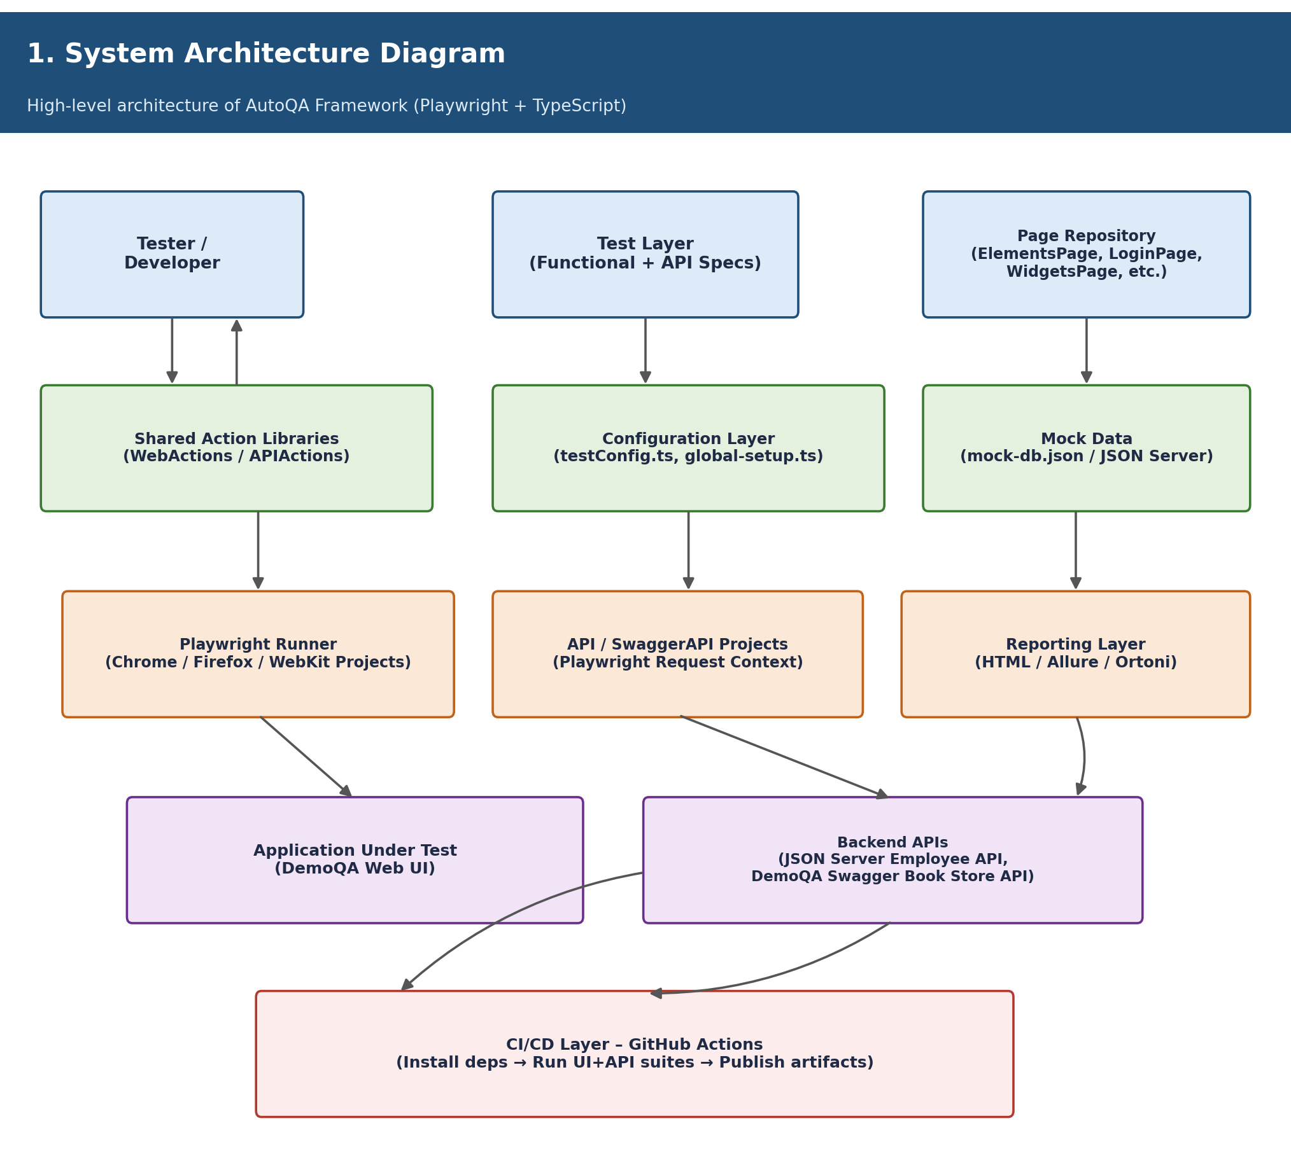
Figure 5.1: System Architecture – AutoQA Framework
5.2 Test Execution Flow
Test execution is built around a custom BaseTest object (lib/BaseTest.ts) that extends Playwright's native test function with framework-specific fixtures. BaseTest.ts uses baseTest.extend<{...}>({...}) to register webActions, loginPage, elementsPage, alertsFrameWindowsPage, widgetsPage, and interactionsPage as fixtures, each constructed from the current page and context and supplied via await use(new ClassName(page, context)). Each spec file imports test from '@lib/BaseTest' rather than from '@playwright/test' directly, and destructures only the fixtures it needs.
Tests are grouped using Playwright's tagging mechanism, with the majority of functional specs tagged { tag: '@Smoke' } and API specs tagged { tag: '@API' } or { tag: '@Swagger' }. This allows the suite to be filtered at execution time — the package.json scripts include test:parallel (--grep @Smoke --project=Chrome) and test:api:qa:run (--project=API --project=SwaggerAPI) — so that a fast smoke subset or a targeted API run can be triggered independently of the full regression suite.
A representative pattern used across specs is a generic navigation helper, webActions.clickByText(text), implemented in WebActions.ts as this.page.getByText(text, { exact: true }).click(). Nearly every functional test begins with loginPage.navigateToURL() followed by one or more webActions.clickByText(...) calls to drill into the relevant DemoQA section before exercising page-specific actions.
The framework also demonstrates network-level testing through Playwright's HAR (HTTP Archive) capability. A dedicated spec (HAR.test.ts) routes the Login page through page.routeFromHAR('har/loginPage.har', { update: true }) to record network traffic on first run, and the same call with { update: false } can replay previously recorded network responses — useful for deterministic testing independent of live network conditions.
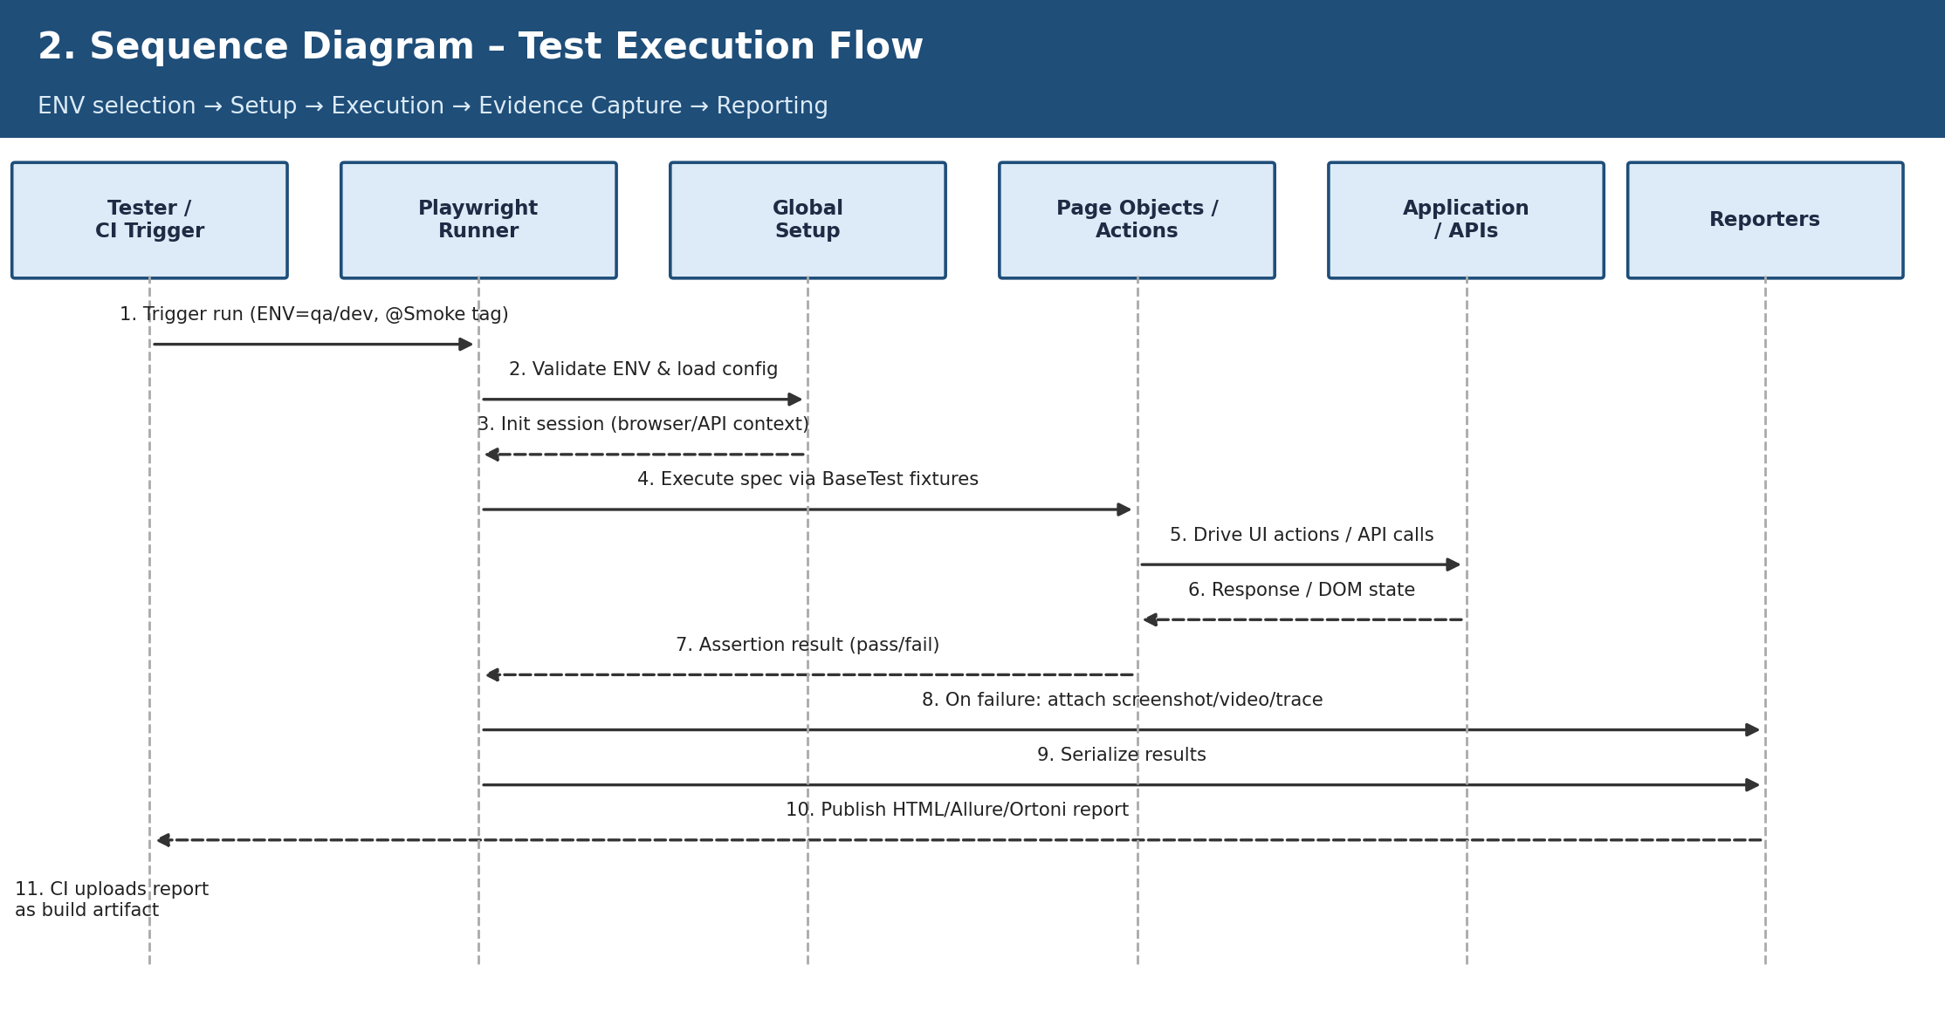
Figure 5.2: Sequence Diagram – Test Execution Flow
5.3 Page Object and Action Design
Page classes such as ElementsPage, LoginPage, WidgetsPage, AlertsFrameWindowsPage, and InteractionsPage isolate locators and domain actions, following the Page Object Model. Each class receives the Playwright page and browserContext through its constructor and exposes readonly Locator properties alongside async action methods. For example, ElementsPage.ts exposes locators for the text box, checkboxes, radio buttons, web-table headers and rows, the registration-form modal, double/right-click buttons, and file upload/download controls, together with methods such as enterFullName(), clickHomeCheckBox(), editCierraEntry(), doubleClickButton(), downloadFile(), and uploadFile().
LoginPage.ts similarly exposes USERNAME_EDITBOX, PASSWORD_EDITBOX, LOGIN_BUTTON, BOOKS_SEARCH_BOX, and LOGIN_ERROR_MESSAGE locators, with methods for navigating to the site root or a specific path (navigateToURL/navigateToPath), logging in using credentials sourced from testConfig combined with webActions.decipherPassword() (an AES decryption helper from WebActions.ts using crypto-js), logging in with explicit credentials (loginWithCredentials), and retrieving the browser's native HTML5 validation message when required fields are left empty (validateEmptyUsername).
WebActions.ts centralizes cross-cutting browser operations: clickByText(text) for text-based navigation, decipherPassword() for AES-based credential decryption (CryptoJS.AES.decrypt against a fixed key against the encrypted value stored in testConfig.password), clickElementJS(locator) for a JS-evaluated click, delay(time) for an explicit wait, and readValuesFromTextFile/writeDataIntoTextFile for file-based I/O. APIActions.ts centralizes request-side helpers: getReqResHeaders() for standard JSON headers, verifyStatusCode() for a 200-OK assertion, verifyResponseBody() for pipe-delimited substring assertions against a JSON response, and verifyResponseHeader() for checking that expected header names are present in the response.
AlertsFrameWindowsPage demonstrates several browser-level interaction patterns: opening a new tab or window via context.waitForEvent('page'), accepting a native prompt dialog via the page.on('dialog', dialog => dialog.accept(text)) event handler, and resolving both single and nested iframes using chained page.frameLocator() calls. WidgetsPage covers autocomplete inputs, hover-triggered tooltips, and legacy HTML <select> elements via selectOption(). InteractionsPage implements drag-and-drop by waiting for the droppable target to reach its 'ui-droppable' ready state (via a dedicated DROPPABLE_READY locator) before invoking Playwright's dragTo() method.
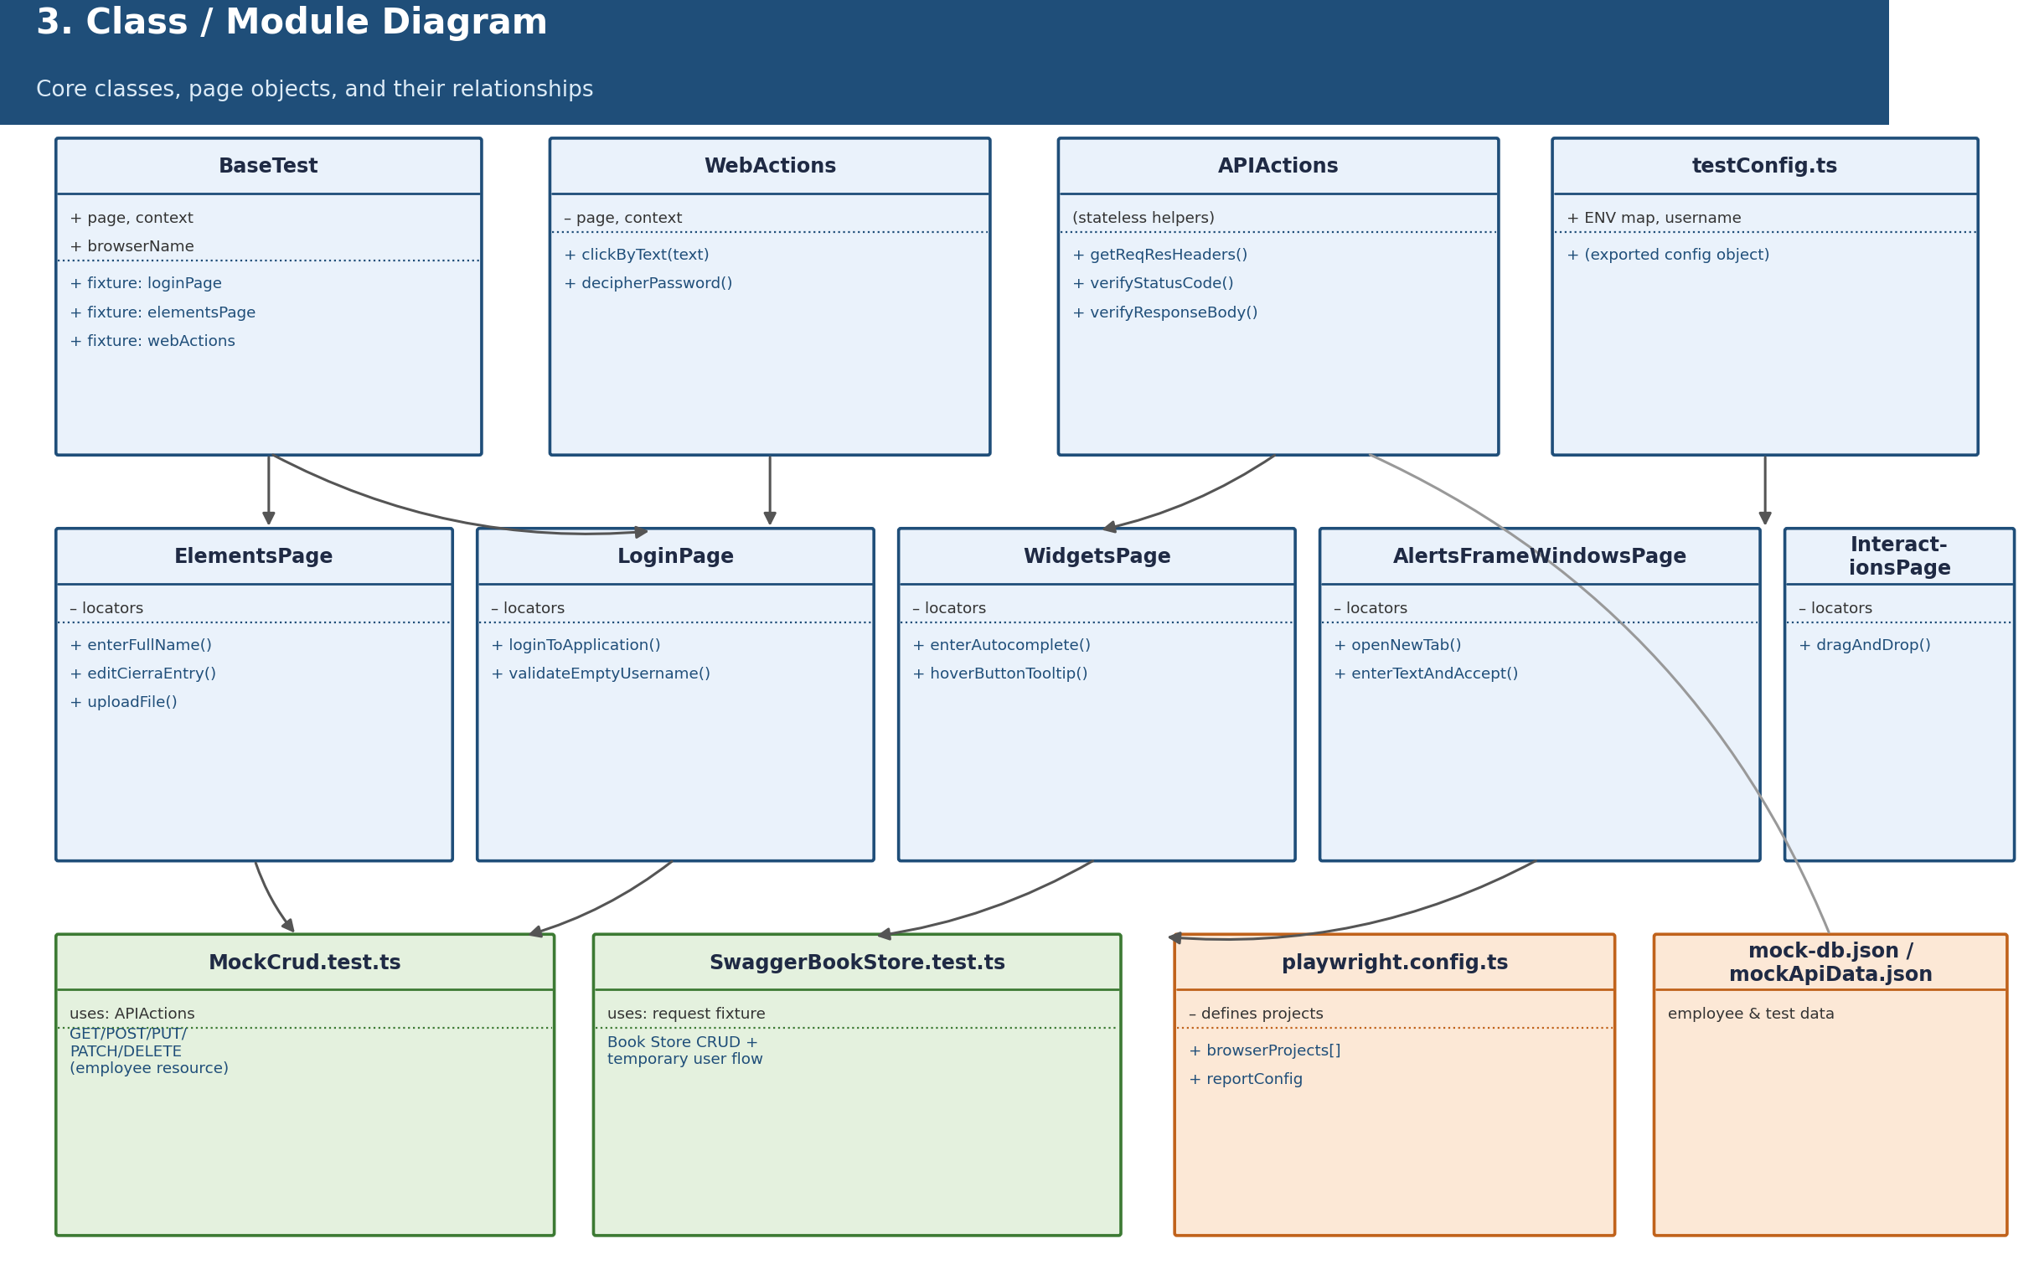
Figure 5.3: Class / Module Diagram – Core Framework Components
5.4 Reporting and CI Design
The reporter configuration in playwright.config.ts registers four reporters: a custom CustomReporterConfig.ts (implementing Playwright's Reporter interface with Winston-based logging of test start/end/step/error events), allure-playwright, the built-in html reporter writing to the html-report folder, and ortoni-report configured with project title, author, and output filename. The GitHub Actions workflow (playwright.yml) installs Node.js 20, installs Chrome, runs UI tests (npm run test:ui:qa) and API tests (npm run test:api:qa) as separate steps, generates the Allure report even if earlier steps fail (if: always()), and uploads the Ortoni report, Allure report, and test-results directory as separate build artifacts.
Chapter 6 – Implementation and Results
6.1 Framework Implementation
The implementation uses a typed Playwright configuration (playwright.config.ts) with explicit environment validation against qa, dev, qaApi, and devApi. Browser projects are generated programmatically for Chrome (chromium with the chrome channel), Firefox, and WebKit via a browserProjects array mapped into Playwright project definitions. Separate API and SwaggerAPI projects match tests/api/MockCrud.test.ts and tests/api/SwaggerBookStore.test.ts respectively. Browser contexts use a 1920×1080 viewport, headless execution, environment-conditional ignoreHTTPSErrors, accepted downloads, failure-only screenshots, retained failure video, and retained failure traces. All functional specs import their test object from a shared @lib/BaseTest module rather than directly from @playwright/test, allowing page objects and action helpers to be injected as fixtures into every test.
// BaseTest.ts (actual)
import { test as baseTest } from '@playwright/test';
import { LoginPage } from '@pages/LoginPage';
import { ElementsPage } from '@pages/ElementsPage';
import { AlertsFrameWindowsPage } from '@pages/AlertsFrameWindowsPage';
import { WidgetsPage } from '@pages/WidgetsPage';
import { InteractionsPage } from '@pages/InteractionsPage';
import { WebActions } from '@lib/WebActions';

const test = baseTest.extend<{
webActions: WebActions;
loginPage: LoginPage;
elementsPage: ElementsPage;
alertsFrameWindowsPage: AlertsFrameWindowsPage;
widgetsPage: WidgetsPage;
interactionsPage: InteractionsPage;
}>({
webActions: async ({ page, context }, use) => {
await use(new WebActions(page, context));
},
loginPage: async ({ page, context }, use) => {
await use(new LoginPage(page, context));
},
elementsPage: async ({ page, context }, use) => {
await use(new ElementsPage(page, context));
},
alertsFrameWindowsPage: async ({ page, context }, use) => {
await use(new AlertsFrameWindowsPage(page, context));
},
widgetsPage: async ({ page, context }, use) => {
await use(new WidgetsPage(page, context));
},
interactionsPage: async ({ page, context }, use) => {
await use(new InteractionsPage(page, context));
}
})
export default test;
Code 6.1: BaseTest.ts – actual fixture registration for all page objects and WebActions
// playwright.config.ts (actual excerpt)
const ENV = process.env.ENV || process.env.npm_config_ENV || `qa`;
const validEnvironments = [`qa`, `dev`, `qaApi`, `devApi`] as const;
type TestEnvironment = typeof validEnvironments[number];
if (!validEnvironments.includes(ENV as TestEnvironment)) {
throw new Error(`Please provide a correct environment value: qa, dev, qaApi, or devApi.`);
}
const currentEnvironment = ENV as TestEnvironment;

const reportConfig: OrtoniReportConfig = {
open: `never`,
base64Image: true,
title: "AutoQA Framework",
filename: "OrtoniHtmlReport",
authorName: "Pradeep Kumar H N",
folderPath: "html-report",
projectName: "AutoQA Framework:End-to-End Test Automation using Playwright and TypeScript",
};

const config: PlaywrightTestConfig = {
globalSetup: `./global-setup`,
timeout: 120000,
retries: 0,
reporter: [[`./CustomReporterConfig.ts`], [`allure-playwright`],
[`html`, { outputFolder: 'html-report', open: 'never' }],
[`ortoni-report`, reportConfig]],
projects: [
...browserProjects.map(({ name, use: browserOptions }) => ({
name,
testMatch: `**/tests/functional/**/*.test.ts`,
use: {
...browserOptions,
baseURL: testConfig[currentEnvironment],
headless: true,
viewport: { width: 1920, height: 1080 },
ignoreHTTPSErrors,
acceptDownloads: true,
screenshot: `only-on-failure` as const,
video: `retain-on-failure` as const,
trace: `retain-on-failure` as const,
},
})),
{ name: `API`, testMatch: `**/tests/api/MockCrud.test.ts`,
use: { baseURL: testConfig.qaApi } },
{ name: `SwaggerAPI`, testMatch: `**/tests/api/SwaggerBookStore.test.ts`,
use: { baseURL: testConfig.qa } }
],
};
export default config;
Code 6.2: playwright.config.ts – actual excerpt (environment validation, reporters, and projects)
6.2 UI Test Implementation
The functional suite covers AlertsFrameWindows, Elements, HAR, Interactions, Login, and Widgets. These tests exercise navigation, forms, checkboxes, radio buttons, web tables, browser alerts, frames, windows, widgets, drag-and-drop, login flows, and network-mocked (HAR) behaviour against DemoQA. Page repository classes keep selectors and workflows separate from assertions, and almost every spec is tagged { tag: '@Smoke' } for fast-feedback execution.
Elements Page Object and Test Spec
// pages/ElementsPage.ts (actual excerpt)
export class ElementsPage {
readonly page: Page;
readonly context: BrowserContext;
readonly FULL_NAME_EDITBOX: Locator;
readonly SUBMIT_BUTTON: Locator;
readonly SUBMITTED_TEXT: Locator;
readonly WEB_TABLES_HEADER: Locator;
readonly WEB_TABLES_EDIT_ICON: Locator;
readonly REGISTRATION_FORM_HEADER: Locator;

constructor(page: Page, context: BrowserContext) {
this.page = page;
this.context = context;
this.FULL_NAME_EDITBOX = page.getByPlaceholder(`Full Name`);
this.SUBMIT_BUTTON = page.getByText(`Submit`);
this.SUBMITTED_TEXT = page.getByText(`Name:AutoTest`, { exact: true });
this.WEB_TABLES_HEADER = page.getByRole('columnheader');
this.WEB_TABLES_EDIT_ICON = page.getByRole('row', { name: 'Cierra' })
.getByTitle('Edit').locator('svg'); // Chaining Locators
this.REGISTRATION_FORM_HEADER = page.getByText('Registration Form');
}

async enterFullName(name: string): Promise<void> {
await this.FULL_NAME_EDITBOX.fill(name);
}
async editCierraEntry(): Promise<void> {
await this.WEB_TABLES_EDIT_ICON.click();
}
async uploadFile(): Promise<void> {
const uploadFilePath = path.join(__dirname, `../../utils/functional/sampleFile.jpeg`);
await this.UPLOAD_BUTTON.setInputFiles(uploadFilePath);
}
async downloadFile(): Promise<void> {
const downloadPromise = this.page.waitForEvent('download');
await this.DOWNLOAD_BUTTON.click();
const download = await downloadPromise;
await download.saveAs(path.join(__dirname, `../../Downloads`, download.suggestedFilename()));
}
}
Code 6.3: ElementsPage.ts – actual locator and action excerpt
// tests/functional/Elements.test.ts (actual excerpt)
import test from '@lib/BaseTest';
import { expect } from '@playwright/test';

test.beforeEach(async ({ loginPage, webActions }) => {
await loginPage.navigateToURL();
await webActions.clickByText('Elements');
});

test(`Verify Text Box`, { tag: '@Smoke' }, async ({ elementsPage, webActions }) => {
await webActions.clickByText('Text Box');
await elementsPage.enterFullName(`AutoTest`);
await elementsPage.clickSubmit();
await expect(elementsPage.SUBMITTED_TEXT).toBeVisible();
});

test(`Verify file upload`, { tag: '@Smoke' }, async ({ elementsPage, webActions }) => {
await webActions.clickByText('Upload and Download');
await elementsPage.uploadFile();
await expect(elementsPage.UPLOADED_FILE_TEXT).toBeVisible();
});
Code 6.4: Elements.test.ts – actual test spec excerpt
Login Page Object, Test Steps, and Browser-Specific Assertions
// tests/functional/Login.test.ts (actual excerpt)
test('Verify the login page loads', { tag: '@Smoke'}, async ({ page, loginPage, webActions }) => {
await loginPage.navigateToPath('login');
await expect(page).toHaveURL(/\/login/);
await expect(loginPage.USERNAME_EDITBOX).toBeVisible();
await expect(page).toHaveTitle('demosite');
});

test(`Verify Book Store Login`, { tag: '@Smoke'}, async ({ loginPage, webActions }) => {
await test.step(`Navigate to Application`, async () => {
await loginPage.navigateToURL();
});
await test.step(`Login to Book Store application`, async () => {
await loginPage.loginToApplication();
});
await test.step(`Verify User is logged in and navigated to Profile page`, async () => {
await expect(loginPage.BOOKS_SEARCH_BOX).toBeVisible();
});
});

test('Verify the login functionality with empty credentials',
async ({ loginPage, webActions, browserName }) => {
await loginPage.navigateToURL();
await webActions.clickByText('Book Store Application');
await loginPage.clickOnLoginMainButton();
const validationMessage = await loginPage.validateEmptyUsername();
if (browserName === 'webkit') {
expect(validationMessage).toContain('Fill out this field');
} else {
expect(validationMessage).toBe('Please fill out this field.');
}
});
Code 6.5: Login.test.ts – actual excerpt (test.step reporting + cross-browser assertion)
HAR-Backed Network Test
A dedicated spec demonstrates Playwright's HAR (HTTP Archive) capability, routing the Login page through a recorded network archive to enable deterministic, network-independent execution.
// tests/functional/HAR.test.ts (actual excerpt)
import test from '@lib/BaseTest';
import { expect } from '@playwright/test';

test(`Generate and verify HAR file for Login Page.`,
async ({ page, loginPage, webActions }) => {
// To record HAR file use below line where "update:true"
// This line creates a directory named har and stores all the har related files in it.
await page.routeFromHAR('har/loginPage.har', { update: true });
// Once you record the har file you can uncomment the below line for Network Replay with update:false
// The below line uses the har file from the recorded directory.
// await page.routeFromHAR('har/loginPage.har', { update: false });
await loginPage.navigateToURL();
await webActions.clickByText('Book Store Application');
await loginPage.clickOnLoginMainButton();
await loginPage.loginToApplication();
await expect(loginPage.BOOKS_SEARCH_BOX).toBeVisible();
});
Code 6.6: HAR.test.ts – actual excerpt (network record/replay for the Login flow)
Widgets Page Object and Test Spec
WidgetsPage.ts covers the autocomplete input, hover-triggered tooltip, and the legacy HTML <select> menu on DemoQA's Widgets section. Widgets.test.ts uses a beforeEach hook to navigate into the Widgets section before each of the three test cases.
// pages/WidgetsPage.ts (actual excerpt)
import { Locator, Page, BrowserContext } from '@playwright/test';

export class WidgetsPage {
readonly page: Page;
readonly context: BrowserContext;
readonly AUTOCOMPLETE_EDITBOX: Locator;
readonly BLUE_COLOUR_TEXT: Locator;
readonly HOVER_BUTTON: Locator;
readonly TOOL_TIP_TEXT: Locator;
readonly OLD_SELECT_MENU: Locator;
readonly MULTISELECT_MENU: Locator;

constructor(page: Page, context: BrowserContext) {
this.page = page;
this.context = context;
this.AUTOCOMPLETE_EDITBOX = page.locator('#autoCompleteSingleInput');
this.BLUE_COLOUR_TEXT = page.getByText('Blue', { exact: true }); // Select Blue colour from Autocomplete editbox
this.HOVER_BUTTON = page.getByRole('button', { name: 'Hover me to see' });
this.TOOL_TIP_TEXT = page.getByRole("tooltip");
this.OLD_SELECT_MENU = page.locator('#oldSelectMenu');
this.MULTISELECT_MENU = page.getByText('Select...');
}

async enterAutocompleteEditbox(textValue: string): Promise<void> {
await this.AUTOCOMPLETE_EDITBOX.fill(textValue);
await this.BLUE_COLOUR_TEXT.click();
}
async hoverButtonForTooltip(): Promise<void> {
await this.HOVER_BUTTON.hover(); // Hover over element
}
async oldStyleSelectColour(colourName: string): Promise<void> {
await this.OLD_SELECT_MENU.selectOption(colourName);
}
}
Code 6.7: WidgetsPage.ts – actual locator and action excerpt
// tests/functional/Widgets.test.ts (actual excerpt)
import test from '@lib/BaseTest';
import { expect } from '@playwright/test';

test.beforeEach(async ({ loginPage, webActions }) => {
await loginPage.navigateToURL();
await webActions.clickByText('Widgets');
});

test(`Verify Auto Complete`, { tag: '@Smoke' }, async ({ widgetsPage, webActions }) => {
await webActions.clickByText('Auto Complete');
await widgetsPage.enterAutocompleteEditbox('Bl');
await expect(widgetsPage.BLUE_COLOUR_TEXT).toBeVisible();
});

test(`Verify Tool Tips`, { tag: '@Smoke' }, async ({ widgetsPage, webActions }) => {
await webActions.clickByText('Tool Tips');
await widgetsPage.hoverButtonForTooltip();
await expect(widgetsPage.TOOL_TIP_TEXT).toContainText(`You hovered over the Button`);
});

test(`Verify Select Menu`, { tag: '@Smoke' }, async ({ widgetsPage, webActions }) => {
await webActions.clickByText('Select Menu');
await widgetsPage.oldStyleSelectColour('Aqua');
});
Code 6.8: Widgets.test.ts – actual test spec excerpt
Interactions Page Object and Test Spec
InteractionsPage.ts implements drag-and-drop within DemoQA's 'Simple' tab panel, waiting for the droppable target to reach its ui-droppable ready state before invoking Playwright's dragTo() method.
// pages/InteractionsPage.ts (actual excerpt)
import { Locator, Page, BrowserContext } from '@playwright/test';

export class InteractionsPage {
readonly page: Page;
readonly context: BrowserContext;
readonly DRAGGABLE: Locator;
readonly DROPPABLE: Locator;
readonly DROPPABLE_READY: Locator;

constructor(page: Page, context: BrowserContext) {
this.page = page;
this.context = context;
const simpleTab = page.getByRole('tabpanel', { name: 'Simple' });
this.DRAGGABLE = simpleTab.locator('#draggable');
this.DROPPABLE = simpleTab.locator('#droppable');
this.DROPPABLE_READY = simpleTab.locator('#droppable.ui-droppable');
}

async dragAndDrop(): Promise<void> {
await this.DROPPABLE_READY.waitFor();
await this.DRAGGABLE.dragTo(this.DROPPABLE);
}
}
Code 6.9: InteractionsPage.ts – actual excerpt (drag-and-drop with readiness wait)
// tests/functional/Interactions.test.ts (actual excerpt)
import test from '@lib/BaseTest';
import { expect } from '@playwright/test';

test(`Verify Interactions Page`, { tag: '@Smoke'}, async ({ loginPage, interactionsPage, webActions }) => {
await loginPage.navigateToURL();
await webActions.clickByText('Interactions'); // Click on Interactions Icon identified via text selector
await webActions.clickByText('Droppable');
await interactionsPage.dragAndDrop();
await expect(interactionsPage.DROPPABLE).toContainText(`Dropped`);
});
Code 6.10: Interactions.test.ts – actual test spec excerpt
Alerts, Frames, and Windows Page Object and Test Spec
AlertsFrameWindowsPage.ts demonstrates several browser-level interaction patterns: opening a new tab or window via context.waitForEvent('page'), accepting a native prompt dialog via the page.on('dialog', ...) event handler, and resolving both single and nested iframes using chained page.frameLocator() calls.
// pages/AlertsFrameWindowsPage.ts (actual excerpt)
import { Locator, Page, BrowserContext } from '@playwright/test';

export class AlertsFrameWindowsPage {
readonly page: Page;
readonly context: BrowserContext;
readonly NEW_TAB_BUTTON: Locator;
readonly NEW_WINDOW_BUTTON: Locator;
readonly PROMPT_ALERT_BUTTON: Locator;
readonly PROMPT_RESULT: Locator;
readonly FRAME_LOCATOR: Locator;
readonly NESTED_CHILDFRAME_LOCATOR: Locator;

constructor(page: Page, context: BrowserContext) {
this.page = page;
this.context = context;
this.NEW_TAB_BUTTON = page.getByText('New Tab');
this.NEW_WINDOW_BUTTON = page.getByText('New Window', { exact: true });
this.PROMPT_ALERT_BUTTON = page.locator('#promtButton');
this.PROMPT_RESULT = page.locator(`#promptResult`);
this.FRAME_LOCATOR = page.frameLocator('#frame2').locator('#sampleHeading');
// Nested Iframe Locator
this.NESTED_CHILDFRAME_LOCATOR = page.frameLocator('#frame1').frameLocator('iframe').getByText('Child Iframe');
}

async openNewTab(): Promise<Page> {
// Start waiting for new page before clicking.
const pagePromise = this.context.waitForEvent('page');
await this.NEW_TAB_BUTTON.click();
const newTab = await pagePromise;
await newTab.waitForLoadState();
return newTab;
}
async openNewWindow(): Promise<Page> {
const pagePromise = this.context.waitForEvent('page');
await this.NEW_WINDOW_BUTTON.click();
const newWindow = await pagePromise;
await newWindow.waitForLoadState();
return newWindow;
}
async enterTextAndAccept(text: string): Promise<void> {
// We have to accept the dialog before we perform the action
this.page.on('dialog', dialog => dialog.accept(text));
await this.PROMPT_ALERT_BUTTON.click();
}
}
Code 6.11: AlertsFrameWindowsPage.ts – actual excerpt (new tab/window, dialogs, nested iframes)
// tests/functional/AlertsFrameWindows.test.ts (actual excerpt)
import test from '@lib/BaseTest';
import { expect } from '@playwright/test';

test(`Verify opening a new tab`, { tag: '@Smoke' }, async ({ loginPage, alertsFrameWindowsPage, webActions }) => {
await loginPage.navigateToURL();
await webActions.clickByText('Alerts, Frame & Windows');
await webActions.clickByText('Browser Windows');
const newTab = await alertsFrameWindowsPage.openNewTab();
expect(newTab.url()).toBe(`https://demoqa.com/sample`);
await expect(newTab.locator(`#sampleHeading`)).toContainText(`This is a sample page`);
await newTab.close();
});

test(`Verify accepting an alert prompt`, { tag: '@Smoke' }, async ({ loginPage, alertsFrameWindowsPage, webActions }) => {
await loginPage.navigateToURL();
await webActions.clickByText('Alerts, Frame & Windows');
await webActions.clickByText('Alerts');
await alertsFrameWindowsPage.enterTextAndAccept(`Hello`);
await expect(alertsFrameWindowsPage.PROMPT_RESULT).toContainText(`You entered Hello`);
});

test(`Verify nested frames`, { tag: '@Smoke' }, async ({ loginPage, alertsFrameWindowsPage, webActions }) => {
await loginPage.navigateToURL();
await webActions.clickByText('Alerts, Frame & Windows');
await webActions.clickByText('Nested Frames');
await expect(alertsFrameWindowsPage.NESTED_CHILDFRAME_LOCATOR).toBeVisible();
});
Code 6.12: AlertsFrameWindows.test.ts – actual test spec excerpt
6.3 API Test Implementation
MockCrud.test.ts validates GET collection, GET by identifier, POST, PUT, PATCH, and DELETE operations against the JSON Server employee resource, using a shared APIActions instance for standard headers. Test data (new/put/patch employee payloads) is externalized into utils/api/mockApiData.json rather than hard-coded inline. SwaggerBookStore.test.ts validates the DemoQA Book Store API: fetching all books, fetching a book by ISBN, rejecting an invalid ISBN, and a full temporary-user lifecycle (register → generate token → authorize → add book → verify → delete book → delete user) wrapped in a try/finally block so that temporary accounts and added books are always cleaned up even if an assertion fails.
// tests/api/MockCrud.test.ts (actual excerpt)
import { APIActions } from '@lib/APIActions';
import mockApiData from '../../utils/api/mockApiData.json';
const apiActions = new APIActions();

test(`Create an employee`, { tag: '@API' }, async ({ request }) => {
let employeeId: number | undefined;
try {
const response = await request.post(`/employees`, {
data: mockApiData.newEmployee,
headers: apiActions.getReqResHeaders(),
});
expect(response.status()).toBe(201);
const employee = await response.json();
employeeId = employee.id;
expect(employee).toEqual(expect.objectContaining(mockApiData.newEmployee));
} finally {
if (employeeId !== undefined) {
await request.delete(`/employees/${employeeId}`, {
headers: apiActions.getReqResHeaders(),
});
}
}
});

test(`Delete an employee`, { tag: '@API' }, async ({ request }) => {
const createResponse = await request.post(`/employees`, {
data: mockApiData.newEmployee, headers: apiActions.getReqResHeaders(),
});
const employeeId = (await createResponse.json()).id;
const response = await request.delete(`/employees/${employeeId}`, {
headers: apiActions.getReqResHeaders(),
});
expect([200, 204]).toContain(response.status());
});
Code 6.13: MockCrud.test.ts – actual excerpt (JSON Server employee CRUD via APIActions)
// tests/api/SwaggerBookStore.test.ts (actual excerpt)
test(`Manage books for a temporary Swagger user`, { tag: '@Swagger' }, async ({ request }) => {
const credentials = {
userName: `autoqa_temp_${Date.now()}`,
password: `AutoQA@2026!Temp`,
};
let userId: string | undefined;
let token: string | undefined;
let bookAdded = false;
const isbn = `9781449325862`;
try {
const registerResponse = await request.post(`/Account/v1/User`, { data: credentials });
expect(registerResponse.status()).toBe(201);
userId = (await registerResponse.json()).userID;

const tokenResponse = await request.post(`/Account/v1/GenerateToken`, { data: credentials });
const tokenBody = await tokenResponse.json();
token = tokenBody.token;

const authorizationHeaders = { Authorization: `Bearer ${token}` };
const addBookResponse = await request.post(`/BookStore/v1/Books`, {
data: { userId, collectionOfIsbns: [{ isbn }] },
headers: authorizationHeaders,
});
expect(addBookResponse.status()).toBe(201);
bookAdded = true;
// ... verify book appears under the user's account ...
} finally {
if (userId && token) {
const authorizationHeaders = { Authorization: `Bearer ${token}` };
if (bookAdded) {
await request.delete(`/BookStore/v1/Book`, {
data: { isbn, userId }, headers: authorizationHeaders,
});
}
await request.delete(`/Account/v1/User/${userId}`, { headers: authorizationHeaders });
}
}
});
Code 6.14: SwaggerBookStore.test.ts – actual excerpt (temporary-user lifecycle with guaranteed cleanup)
6.4 Configuration, Data, and Diagnostics
testConfig.ts stores environment endpoints (qa, dev, qaApi, devApi), the application username, an AES-encrypted password string, a shared element wait timeout, and placeholder database connection fields reserved for future use. mock-db.json provides local employee/department/attendance data served by json-server; mockApiData.json externalizes the specific payloads (newEmployee, putEmployee, patchEmployee) used by MockCrud.test.ts. CustomReporterConfig.ts implements Playwright's Reporter interface using Winston to log test-begin, test-end, step-begin, and error events both to console and to logs/info.log, giving a plain-text execution trail alongside the structured HTML/Allure/Ortoni reports.
// testConfig.ts (actual)
export const testConfig = {
qa: `https://demoqa.com`,
dev: ``,
qaApi: `http://127.0.0.1:3000`,
devApi: ``,
username: `demouat@gmail.com`,
password: `U2FsdGVkX18/eMdsOJpvI4hJZ/w7hNgwSRFaDvAcZx4=`,
waitForElement: 120000,
dbUsername: ``, dbPassword: ``, dbServerName: ``, dbPort: ``, dbName: ``
}
Code 6.15: testConfig.ts – actual excerpt (environment map + encrypted credential)
// WebActions.ts (actual excerpt)
export class WebActions {
async decipherPassword(): Promise<string> {
const key = `SECRET`;
return CryptoJS.AES.decrypt(testConfig.password, key).toString(CryptoJS.enc.Utf8);
}
async clickByText(text: string): Promise<void> {
await this.page.getByText(text, { exact: true }).click();
}
}

// APIActions.ts (actual excerpt)
export class APIActions {
getReqResHeaders(): Record<string, string> {
return { 'Content-Type': `application/json` };
}
async verifyStatusCode(response: APIResponse): Promise<void> {
await expect(response, `200 Status code was not displayed.`).toBeOK();
}
}
Code 6.16: WebActions.ts and APIActions.ts – actual excerpts (shared UI/API helpers)

6.5 Continuous Integration
The GitHub Actions workflow (playwright.yml) triggers on pushes and pull requests targeting main. It checks out the repository, installs Node.js 20 with npm caching, runs npm ci, installs Chrome with dependencies, prepares the Ortoni report output folder, runs UI tests (npm run test:ui:qa) and API tests (npm run test:api:qa) as separate steps, generates the Allure report unconditionally (if: always()), and uploads the Ortoni report file, the full Allure report directory, and the test-results directory as three separate build artifacts.
# .github/workflows/playwright.yml (actual excerpt)
name: Playwright tests
on:
push: { branches: [main] }
pull_request: { branches: [main] }
jobs:
test:
runs-on: ubuntu-latest
steps:
- uses: actions/checkout@v4
- uses: actions/setup-node@v4
with: { node-version: "20", cache: npm }
- run: npm ci
- name: Install Playwright Chrome
run: npx playwright install --with-deps chrome
- name: Run UI tests
run: npm run test:ui:qa
env: { CI: true }
- name: Run API tests
run: npm run test:api:qa
env: { CI: true }
- name: Generate Allure report
if: always()
run: npm run allureReport:generate
- uses: actions/upload-artifact@v4
if: always()
with: { name: ortoni-report, path: html-report/OrtoniHtmlReport.html }
- uses: actions/upload-artifact@v4
if: always()
with: { name: allure-report, path: allure-report/ }
- uses: actions/upload-artifact@v4
if: always()
with: { name: test-results, path: test-results/ }
Code 6.17: playwright.yml – actual GitHub Actions workflow

6.6 Results and Generated Artifacts
The workspace produces three independent, browsable report artifacts — the Playwright HTML report, the Allure report, and the Ortoni HTML report — alongside the test-results directory containing failure screenshots, videos, and traces. These artifacts demonstrate that the framework is not limited to source code: it also provides an operational feedback loop for test execution and diagnosis, and all three are uploaded automatically by the CI workflow on every run.
Artifact | Generated By | Purpose
html-report/ | Playwright built-in HTML Reporter | Browsable pass/fail summary per test and browser
allure-report/ , allure-results/ | allure-playwright + allure-commandline | Structured, filterable historical test reporting
html-report/OrtoniHtmlReport.html | ortoni-report | Additional consolidated HTML view of results, titled “AutoQA Framework”
test-results/ (screenshots, videos, traces) | Playwright tracing | Failure evidence for root-cause diagnosis
har/loginPage.har | page.routeFromHAR() | Recorded network traffic for deterministic Login-page replay
logs/info.log | Winston (via CustomReporterConfig.ts) | Plain-text execution log of test/step begin, end, and errors
Table 6.1: Generated Report and Diagnostic Artifacts
6.7 Report Screenshots (Allure, Playwright HTML, Ortoni)
The following pages are reserved for pasting screenshots of the three generated report types — the Allure report, the default Playwright HTML report, and the Ortoni report — captured after a local or CI test run. Replace the placeholder box on each page with the corresponding screenshot.
Allure Report
[ Paste screenshot here ]
Insert a screenshot of the Allure report dashboard/overview here (e.g., allure serve or the allure-report/index.html view).
Allure Report – Screenshot
Playwright HTML Report
[ Paste screenshot here ]
Insert a screenshot of the default Playwright HTML report here (from html-report/index.html, opened via npx playwright show-report html-report).
Playwright HTML Report – Screenshot
Ortoni Report
[ Paste screenshot here ]
Insert a screenshot of the Ortoni HTML report here (html-report/OrtoniHtmlReport.html).
Ortoni Report – Screenshot
Chapter 7 – Testing
7.1 Test Strategy
Testing is organized by system boundary and execution purpose. UI tests validate behaviour through a real browser, API tests validate service contracts directly against JSON Server and the DemoQA Swagger Book Store, and CI validates that the same npm scripts work in a clean Ubuntu runner. Smoke-tagged tests (@Smoke) can be selected with --grep @Smoke (see package.json's test:parallel and test:serial scripts) and can be run in parallel (default) or serial (--workers=1) mode. API tests are tagged @API (MockCrud) or @Swagger (SwaggerBookStore) and run through dedicated API / SwaggerAPI Playwright projects, started alongside the local JSON Server via start-server-and-test.
7.2 Coverage Matrix
UI coverage includes elements, interactions, alerts and frames, widgets, login, and HAR-backed flows. API coverage includes local employee collection/identifier CRUD operations (GET, POST, PUT, PATCH, DELETE) plus departments and attendance lookups, and Swagger Book Store workflows including full temporary-user lifecycle management. Cross-browser coverage is configured for Chrome, Firefox, and WebKit, including at least one explicit browser-conditional assertion (Login – empty credentials) that accounts for WebKit's differing native validation message text.
Test Spec | Representative Test Cases | Tag
Elements.test.ts | Text Box, Check Box, Radio Button, Web Tables, Buttons, file download, file upload, Home link new tab | @Smoke
Widgets.test.ts | Auto Complete, Tool Tips, Select Menu | @Smoke
Interactions.test.ts | Interactions Page – drag and drop onto Droppable | @Smoke
AlertsFrameWindows.test.ts | New tab, new window, accepting an alert prompt, single frame, nested frames | @Smoke
Login.test.ts | Login page loads, Book Store login (test.step flow), invalid credentials, empty credentials (cross-browser) | @Smoke (mixed)
HAR.test.ts | Generate and verify HAR file for Login Page (network record/replay) | —
MockCrud.test.ts | GET all/one employee, Create/Replace/Patch/Delete employee, Get departments, Get attendance | @API
SwaggerBookStore.test.ts | Get all books, Get book by ISBN, Reject invalid ISBN, Manage books for a temporary user | @Swagger
Table 7.1: Test Coverage Matrix by Specification File
7.3 Detailed Test Cases
The following tables list each automated test case reviewed in the framework, along with its execution steps, expected result, and observed status. Steps are summarized from the actual test specifications (Chapter 6); expected results reflect the assertions coded in each test.
7.3.1 UI Test Cases – Elements.test.ts
ID | Test Case | Steps (Summary) | Expected Result | Status
TC-01 | Verify Text Box | Navigate to Elements > Text Box; enter full name 'AutoTest'; click Submit | Submitted text 'Name:AutoTest' is visible | Pass
TC-02 | Verify Check Box | Navigate to Elements > Check Box; select the 'Home' checkbox | Result text contains 'home' | Pass
TC-03 | Verify Radio Button | Navigate to Elements > Radio Button | The 'No' radio button is disabled | Pass
TC-04 | Verify Web Tables | Navigate to Web Tables; verify first column header; click Edit on 'Cierra' row; close form | First header reads 'First Name'; Registration Form modal becomes visible, then closes | Pass
TC-05 | Verify Buttons | Navigate to Buttons; double-click and right-click the respective buttons | Double-click and right-click confirmation texts are visible | Pass
TC-06 | Verify file download | Navigate to Upload and Download; trigger file download | Download event fires and file is saved locally | Pass
TC-07 | Verify file upload | Navigate to Upload and Download; upload sampleFile.jpeg | Uploaded file name 'sampleFile.jpeg' is visible | Pass
TC-08 | Verify Home link opens in a new tab | Navigate to Links; click Home link | New tab opens with URL https://demoqa.com/ | Pass
Table 7.2: Detailed Test Cases – Elements.test.ts
7.3.2 UI Test Cases – Widgets, Interactions, and HAR
ID | Test Case | Steps (Summary) | Expected Result | Status
TC-09 | Verify Auto Complete | Navigate to Widgets > Auto Complete; type 'Bl' into the editbox | 'Blue' colour suggestion becomes visible | Pass
TC-10 | Verify Tool Tips | Navigate to Widgets > Tool Tips; hover over the button | Tooltip text contains 'You hovered over the Button' | Pass
TC-11 | Verify Select Menu | Navigate to Widgets > Select Menu; select 'Aqua' from the legacy dropdown | Selected option is applied without error | Pass
TC-12 | Verify Interactions Page (drag-and-drop) | Navigate to Interactions > Droppable; wait for droppable readiness; drag draggable onto droppable | Droppable element contains text 'Dropped' | Pass
TC-13 | Generate and verify HAR file for Login Page | Route Login page through routeFromHAR (record mode); navigate, log in | Network traffic recorded to har/loginPage.har; Book Store search box is visible | Pass
Table 7.3: Detailed Test Cases – Widgets, Interactions, and HAR
7.3.3 UI Test Cases – AlertsFrameWindows.test.ts
ID | Test Case | Steps (Summary) | Expected Result | Status
TC-14 | Verify opening a new tab | Navigate to Alerts, Frame & Windows > Browser Windows; open a new tab | New tab URL is https://demoqa.com/sample; heading contains 'This is a sample page' | Pass
TC-15 | Verify opening a new window | Navigate to Browser Windows; open a new window | New window URL is https://demoqa.com/sample | Pass
TC-16 | Verify accepting an alert prompt | Navigate to Alerts; trigger prompt, enter 'Hello', accept dialog | Prompt result text contains 'You entered Hello' | Pass
TC-17 | Verify a frame | Navigate to Frames | Frame content displays text 'This is a sample page' | Pass
TC-18 | Verify nested frames | Navigate to Nested Frames | Nested child-iframe text is visible | Pass
Table 7.4: Detailed Test Cases – AlertsFrameWindows.test.ts
7.3.4 UI Test Cases – Login.test.ts
ID | Test Case | Steps (Summary) | Expected Result | Status
TC-19 | Verify the login page loads | Navigate to /login path directly | URL matches /login; username/password/login controls visible; page title is 'demosite' | Pass
TC-20 | Verify Book Store Login | Navigate to app (test.step); click Book Store icon (test.step); click Login (test.step); submit credentials (test.step); verify (test.step) | User is logged in; Books search box is visible | Pass
TC-21 | Verify login with invalid credentials | Navigate to Book Store; submit an invalid email/password combination | Login error message 'Invalid username or password!' is visible | Pass
TC-22 | Verify login with empty credentials | Navigate to Book Store; submit the login form with both fields empty | Native validation message is returned; assertion branches on browserName (WebKit vs. Chromium/Firefox wording) | Pass
Table 7.5: Detailed Test Cases – Login.test.ts
7.3.5 API Test Cases – MockCrud.test.ts (Employee CRUD)
ID | Test Case | Steps (Summary) | Expected Result | Status
TC-23 | Get all employees | GET /employees | Status 200; response is an array of 5 employees, including the seeded record | Pass
TC-24 | Get an employee | GET /employees/{employeeIdForGet} | Status 200; returned record matches the seeded employee (id, name, department) | Pass
TC-25 | Create an employee | POST /employees with mockApiData.newEmployee; delete in finally block | Status 201; response object matches the posted payload | Pass
TC-26 | Replace an employee | POST to create, then PUT /employees/{id} with mockApiData.putEmployee | Status 200; response reflects the fully replaced fields | Pass
TC-27 | Partially update an employee | POST to create, then PATCH /employees/{id} with mockApiData.patchEmployee | Status 200; response merges original fields with patched fields (status, salary) | Pass
TC-28 | Delete an employee | POST to create, then DELETE /employees/{id}; re-GET the same id | DELETE returns 200/204; subsequent GET returns 404 | Pass
TC-29 | Get all departments | GET /departments | Status 200; response contains 4 departments, including 'Engineering' managed by 'Sarah Connor' | Pass
TC-30 | Get all attendance records | GET /attendance | Status 200; response contains 3 records, including employeeId 1 with status 'present' | Pass
Table 7.6: Detailed Test Cases – MockCrud.test.ts (Employee CRUD)
7.3.6 API Test Cases – SwaggerBookStore.test.ts (Book Store API)
ID | Test Case | Steps (Summary) | Expected Result | Status
TC-31 | Get all books | GET /BookStore/v1/Books | Status 200; books array is non-empty; first book has isbn/title/author fields | Pass
TC-32 | Get a book by ISBN | GET /BookStore/v1/Book?ISBN=9781449325862 | Status 200; response matches known title 'Git Pocket Guide' by 'Richard E. Silverman' | Pass
TC-33 | Reject an invalid ISBN | GET /BookStore/v1/Book?ISBN=invalid-isbn | Status 400 returned for the malformed ISBN | Pass
TC-34 | Manage books for a temporary Swagger user | Register user → generate token → authorize → add book by ISBN → verify under account → delete book → delete user (try/finally cleanup) | Each step returns its expected status (201/200); book appears under the user's account; cleanup always executes | Pass
Table 7.7: Detailed Test Cases – SwaggerBookStore.test.ts (Book Store API)

7.4 Defect Diagnostics and Evidence
The framework uses explicit environment validation (playwright.config.ts throws on an invalid ENV), centralized timeout configuration (120-second global timeout, plus testConfig.waitForElement), failure-only screenshots, retained failure video and traces, Winston-based console/file logging through CustomReporterConfig.ts, and CI artifact retention for all three report types. These mechanisms reduce the time between a failed check and a reproducible diagnosis. The generated reports in the workspace — illustrated in Section 6.7 — provide evidence for reviewing execution history and failure attachments.
Chapter 8 – Conclusion and Future Enhancements
8.1 Summary
AutoQA Framework provides a coherent, reusable, and CI-ready approach to end-to-end UI and API automation. Playwright and TypeScript form the execution foundation, while a fixture-based BaseTest, page objects, shared action classes (WebActions, APIActions), typed configuration, local mock data, and three parallel reporters (Playwright HTML, Allure, Ortoni) provide maintainability and observability. The reviewed page objects, test specs, configuration files, and CI workflow confirm consistent use of the Page Object Model, tag-based test selection (@Smoke, @API, @Swagger), Cucumber-style test.step() reporting, cross-browser-aware assertions, HAR-based network mocking, and guaranteed cleanup of API-created test data via try/finally — demonstrating the practical value of keeping UI and API checks under one test runner.
8.2 Future Enhancements
Future work may add visual regression baselines, accessibility checks, schema validation, contract testing, test-data factories, database assertions (the dbUsername/dbPassword/dbServerName fields in testConfig.ts are currently unused placeholders), parallel sharding, environment secrets through CI storage, richer dashboard metrics, and a formal test-case traceability matrix. Additional device profiles and mobile browser projects can extend coverage.
8.3 Limitations
Public DemoQA tests depend on external availability and may change independently of the framework. Browser binaries and network access are required for full execution. The local JSON Server is intentionally lightweight and does not model production authentication, concurrency, or database constraints. The current project is a test automation framework and not a production application.
The project meets its central objective: it supplies a structured automation foundation that can be executed locally and in CI, covers representative UI and API scenarios, and produces evidence that supports engineering decisions.
References
- Microsoft Playwright Documentation, https://playwright.dev/docs/intro
- Playwright Test Configuration Documentation, https://playwright.dev/docs/test-configuration
- Playwright Fixtures Documentation, https://playwright.dev/docs/test-fixtures
- Playwright HAR Replay Documentation, https://playwright.dev/docs/mock#mocking-with-har-files
- TypeScript Documentation, https://www.typescriptlang.org/docs/
- GitHub Actions Documentation, https://docs.github.com/en/actions
- JSON Server Documentation, https://github.com/typicode/json-server
- Allure Report Documentation, https://allurereport.org/docs/
- Ortoni Report (npm), https://www.npmjs.com/package/ortoni-report
- Winston Logging Library, https://github.com/winstonjs/winston
- crypto-js (npm), https://www.npmjs.com/package/crypto-js
- DemoQA, https://demoqa.com/
- Project source code repository: https://github.com/FamousAnonymous/AutoQAFramework

